Biblioteca Clemencia Conejo Chacón
Nuevas Adquisiciones
febrero, 2012

371.91446  H823d  Developmental and adapted physical activity assessment. / Michael Horvat, Martin E. Block, Luke E. Kelly. EE. UU. : Human Kinetics, 2007. | 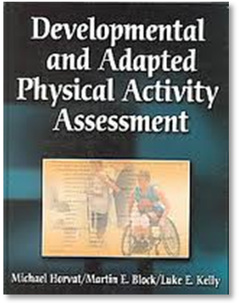
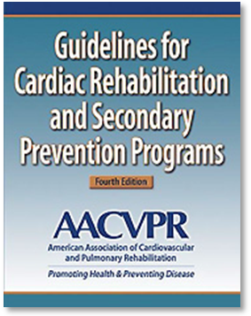 | 616.1203  G946g  Guidelines for cardiac rehabilitation and secondary prevention programs / American Association of Cardiovascular and Pulmonary Rehabilitation. 4. ed. EE. UU. : Human Kinetics, c2004.

371.91446  H823d  Developmental and adapted physical activity assessment. / Michael Horvat, Martin E. Block, Luke E. Kelly. EE. UU. : Human Kinetics, 2007. | 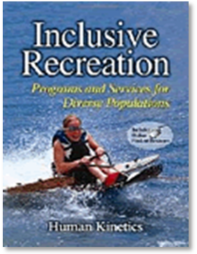
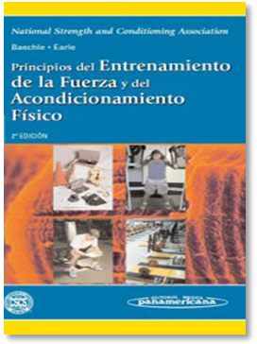 | 613.71  P957p  Principios del entrenamiento de la fuerza y del acondicionamiento físico / Thomas R. Baechle, Roger W. Earle, editores. Buenos Aires, Arg. : Editorial Médica Panamericana, c2007. .

